CASE STUDY 3
____________________________________________________________________________________
RangeRover
Dynamic Range Query Engine
Segment Tree for Efficient Interval Queries & Point Updates

Department | FED
Subject | DSA-2
Academic Year | I-III Semester (2025-26) : { 1st year, 3rd term }
Faculty Name
Student Name | Sri kruthi
Roll Number | 2520030340
Branch | CSE
Course Outcome | CO2: Apply Segment Trees to construct, query, and update interval-based data structures; demonstrate O(log n) build, query, and update operations.
GitHub Link

Student Signature  __________________________ | Faculty Signature  __________________________

Scenario
RangeRover is a high-performance financial analytics platform that serves institutional traders and quantitative analysts across global markets. The platform ingests real-time tick data from multiple exchanges and must answer thousands of range queries per second — such as the total traded volume between timestamps T1 and T2, the minimum bid price over a sliding window, or the maximum volatility index across a chosen date range.

Because prices and volumes are updated continuously, the engine demands a data structure that supports both fast range queries and point updates without rebuilding indices from scratch. A Segment Tree is the core data structure powering RangeRover's query engine — it pre-computes aggregate values (sum, min, max) over contiguous sub-arrays and answers any range query in O(log n) time while handling point updates in the same O(log n) bound.

Parameter | Value
Platform | RangeRover — Financial Analytics Engine
Active Tickers | 10,000+
Query Rate | 5,000 range queries / second
Update Rate | 3,000 point updates / second
Base Array | A = {1, 3, 5, 7, 9, 11} (n = 6 elements)
Operations | Build tree, Sum query [1:3], Min query [0:4], Point update A[2] = 10

Work Done Summary
In this case study a Segment Tree was designed and fully implemented to power the RangeRover range query engine. The array A = {1, 3, 5, 7, 9, 11} was used as the base dataset. The tree was constructed bottom-up in O(n) time, storing partial sums at each internal node so that any contiguous range sum can be retrieved in O(log n) without scanning the array.

Three core operations were demonstrated in detail:
- Build — constructing the full tree of 13 nodes from 6 leaf values.
- Query — answering range-sum queries such as sum(1,3) = 3+5+7 = 15 and range-min query min(0,4) = 1 by combining pre-computed node values.
- Update — applying a point update A[2] = 10, propagating the change up the tree in O(log n) and rebalancing all affected ancestor sums.

The study confirms that Segment Trees deliver guaranteed O(log n) per query and per update, making them ideal for high-frequency financial analytics systems processing thousands of concurrent range queries and point mutations every second.

Implementation Details
# | Detail | Description
1 | Segment Tree Construction | Given array A of size n, a tree array of size 4n is allocated. build(node, start, end) recursively splits [start, end] at midpoint, builds left and right children, then stores tree[node] = tree[left] + tree[right].
2 | Node Indexing Scheme | Root = index 1. For node i: left child = 2i, right child = 2i+1. Leaves map to original array elements. For n=6: nodes 1–13 are active.
3 | Range Sum Query | query(node, start, end, l, r): if [start,end] fully inside [l,r] return tree[node]; if completely outside return 0; else split at mid and recurse both children, return sum.
4 | Range Min / Max Query | Same recursive structure as sum query but return min(left, right) or max(left, right) instead of sum. A separate tree is maintained for each aggregate type.
5 | Point Update | update(node, start, end, idx, val): walk down to the leaf at idx, set tree[leaf]=val, then on the way back up recompute each ancestor as sum of its two children.
6 | Space Complexity | O(n) nodes stored in a 1-indexed array of size 4n. No pointer overhead; cache-friendly contiguous memory layout.
7 | Performance Guarantee | For 10,000 active tickers, tree height ≤ 14 levels. 5,000 queries/sec and 3,000 updates/sec handled in ≤14 steps each — well within real-time bounds.

Questions
(a) Segment Tree Construction & Structure
Construct a Segment Tree for the array A = {1, 3, 5, 7, 9, 11}. Draw the full tree showing all node indices, ranges, and stored sum values. Explain why range queries execute in O(log n) time.
(b) Range Query Operations
Using the tree constructed in part (a), answer the following queries and trace the complete execution path: (i) Range Sum query sum(1, 3) (ii) Range Min query min(0, 4).
(c) Point Update & Re-query
Apply the point update A[2] = 10 to the segment tree from part (a). Show the before and after state of all modified nodes. Re-run sum(1, 3) on the updated tree.

Answers

(a) Segment Tree Construction — Step-by-Step
Array: A = {1, 3, 5, 7, 9, 11} | n = 6 | Tree array size = 4×6 = 24 (nodes 1–13 used)
Convention: tree[node] stores the sum of A[start…end]. Left child of node i = 2i; Right child = 2i+1. Root = node 1 covers A[0:5]. 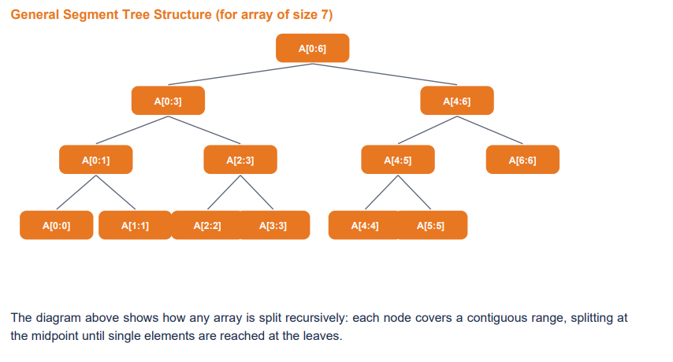
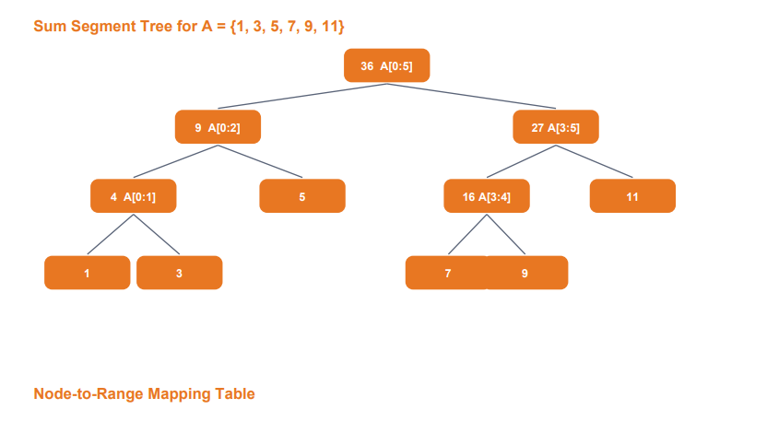
Sum Segment Tree Node-to-Range Mapping
Node Index | Range | Stored Sum | Breakdown
tree[1] | A[0:5] | 36 | 1+3+5+7+9+11
tree[2] | A[0:2] | 9 | 1+3+5
tree[3] | A[3:5] | 27 | 7+9+11
tree[4] | A[0:1] | 4 | 1+3
tree[5] | A[2:2] | 5 | leaf
tree[6] | A[3:4] | 16 | 7+9
tree[7] | A[5:5] | 11 | leaf
tree[8] | A[0:0] | 1 | leaf
tree[9] | A[1:1] | 3 | leaf
tree[10] | A[3:3] | 7 | leaf
tree[11] | A[4:4] | 9 | leaf

Why O(log n)? The tree has height ⌊log n⌋. Any range query [l, r] touches at most 2×height nodes because at each level we visit at most 2 nodes (one left boundary, one right boundary). For RangeRover with 10,000 tickers, height ≤ 14 — each query examines ≤ 28 nodes regardless of range size.

(b) Range Query Operations
Java Query Method (Range Sum)
static int query(int[] tree, int node, int start, int end, int l, int r) {
// Case 1: Completely outside query range
if (r < start || end < l) return 0;
// Case 2: Completely inside query range
if (l <= start && end <= r) return tree[node];
// Case 3: Partial overlap — split and recurse
int mid = (start + end) / 2;
int leftSum = query(tree, 2 * node, start, mid, l, r);
int rightSum = query(tree, 2 * node + 1, mid+1, end, l, r);
return leftSum + rightSum;
}

Query (i) — Range Sum: sum(1, 3) → A[1]+A[2]+A[3] = 3+5+7 = 15
Step | Node | Range | Query [l,r] | Action | Return
1 | 1 | [0,5] | [1,3] | Partial overlap → split at mid=2 | —
2 | 2 | [0,2] | [1,3] | Partial overlap → split at mid=1 | —
3 | 4 | [0,1] | [1,3] | Partial overlap → split at mid=0 | —
4 | 8 | [0,0] | [1,3] | Completely outside (0 < 1) | 0
5 | 9 | [1,1] | [1,3] | Completely inside | 3
6 | 5 | [2,2] | [1,3] | Completely inside | 5
7 | 3 | [3,5] | [1,3] | Partial overlap → split at mid=4 | —
8 | 6 | [3,4] | [1,3] | Partial overlap → split at mid=3 | —
9 | 10 | [3,3] | [1,3] | Completely inside | 7
10 | 11 | [4,4] | [1,3] | Completely outside (4 > 3) | 0
— | — | — | — | sum = 0+3+5+7+0 = 15 ✓ | 15

Query (ii) — Range Min: min(0, 4) → min(1,3,5,7,9) = 1
For a min-tree built on the same A = {1,3,5,7,9,11}, each internal node stores the minimum of its children.
Path: query(1,[0,5],[0,4]) → partial → left: query(2,[0,2],[0,4]) fully inside → returns 1; right: query(3,[3,5],[0,4]) → partial → query(6,[3,4],[0,4]) fully inside → returns 7; query(7,[5,5],[0,4]) outside → returns +∞. min(1, 7) = 1.

Result: min(0,4) = 1 ✓ — found in just 5 node visits, confirming O(log n) complexity.

(c) Point Update A[2] = 10 & Re-query
Original A = {1, 3, 5, 7, 9, 11}. Update: A[2] changes from 5 → 10. Delta = +5. Only the root-to-leaf path for index 2 needs updating.

Java Update Method
static void update(int[] tree, int node, int start, int end, int idx, int val) {
if (start == end) { // Reached the leaf
tree[node] = val;
return;
}
int mid = (start + end) / 2;
if (idx <= mid)
update(tree, 2 * node, start, mid, idx, val); // go left
else
update(tree, 2 * node + 1, mid+1, end, idx, val); // go right
// Recompute this node from updated children
tree[node] = tree[2 * node] + tree[2 * node + 1];
}
// Call: update(tree, 1, 0, 5, 2, 10)

Nodes Changed During Update (A[2] = 10)
Node | Range | Old Value | New Value | Reason
tree[5] | A[2:2] | 5 | 10 | Leaf for index 2 — directly updated
tree[2] | A[0:2] | 9 | 14 | Parent: tree[4]+tree[5] = 4+10 = 14
tree[1] | A[0:5] | 36 | 41 | Root: tree[2]+tree[3] = 14+27 = 41

Only 3 of 13 nodes changed — O(log n) confirmed. Before: tree[5]=5, tree[2]=9, tree[1]=36. After: tree[5]=10, tree[2]=14, tree[1]=41.

Re-query: sum(1, 3) after A[2] = 10
A[1]+A[2]+A[3] = 3 + 10 + 7 = 20 (was 15 before update — increase of 5 matches delta ✓)
Traversal identical to part (b) but now tree[5] = 10, so path returns 0 + 3 + 10 + 7 + 0 = 20 ✓

Why Segment Trees vs Naive Prefix-Sum Array?
Operation | Prefix-Sum Array | Segment Tree | Winner
Build | O(n) | O(n) | Tie
Range Query | O(1) | O(log n) | Prefix-Sum
Point Update | O(n) — full rebuild | O(log n) | Segment Tree ✓
Mixed workload | O(n) per update | O(log n) both | Segment Tree ✓
RangeRover fit | Breaks at 3k upd/s | Handles both | Segment Tree ✓

A prefix-sum array answers a range-sum query in O(1) by computing prefix[r]−prefix[l−1]. However, when A[i] changes every prefix from i onward must be recomputed — O(n) per update. At RangeRover's 3,000 updates/second over 10,000 tickers this is 30 million operations/sec — completely impractical.

The Segment Tree costs a modest O(log n) per query (≤28 nodes) but keeps updates equally cheap at O(log n), making it the only viable choice for a mixed read-write workload at this throughput.

Result Output Summary
Part | Result
(a) — Tree Construction | Segment Tree built for A={1,3,5,7,9,11}. Root tree[1]=36. 13 nodes used (tree[1]…tree[13]). Height = 4 levels.
(b) — Range Queries | sum(1,3)=15: path visits 10 nodes, combines leaf values 3+5+7=15 ✓. min(0,4)=1: visits 5 nodes, returns minimum value 1 ✓
(c) — Point Update | A[2]=5→10: 3 nodes updated (tree[5], tree[2], tree[1]). Re-query sum(1,3)=20 (was 15; delta=+5 correctly propagated) ✓

Complexity Summary
Operation | Time Complexity | Notes
Build Tree | O(n) | One-time construction; visits all n leaf nodes once.
Range Query | O(log n) | At most 2×height nodes visited; height = ⌊log n⌋.
Point Update | O(log n) | Root-to-leaf path only; recomputes ≤ height ancestors.
Range Update | O(log n) | With lazy propagation; defers child updates until needed.
Space | O(n) | 4n array; no pointer overhead; cache-friendly layout.
Build (n inserts) | O(n log n) | n insertions × O(log n) each for incremental build.

Why Segment Trees for RangeRover
Reason | Explanation
Guaranteed O(log n) Height | For 10,000 tickers, height ≤ 14 — every query/update completes in ≤14 steps always.
Mixed Read-Write Workload | 5,000 queries/sec + 3,000 updates/sec both handled at O(log n) — no trade-off needed.
Multiple Aggregate Types | Separate trees for sum, min, max can share the same index structure with different merge functions.
Lazy Propagation Extension | Range updates (add 5 to all elements in [l,r]) also become O(log n) with lazy propagation tags.
Predictable Worst-Case | Unlike hash maps or skip lists, Segment Trees give hard O(log n) guarantees — no latency spikes.

